Registration Form

Arizona Society

Of Pathologists
2020 Fall Virtual Conference
November 14, 2020

Name:______________________________________________________

Address:____________________________________________________

City:____________________________State:______Zip______________

Email: ______________________________________________________
PLEASE NOTE: A link and instructions to join the virtual meeting on Zoom will be sent to the email you provide with this registration.

ASP Active Member $75.00 ______
If received after11/1 $85.00 ______
ASP Retired Member $35.00 ______
If received after11/1 $45.00 ______
ASP Resident Member No Charge ____
Non-ASP Member $125.00 ______
If received after 11/1 $150.00 ______

Make check payable to the Arizona Society of Pathologists, or pay by Visa, MasterCard or AMEX and send to: 2401 W Peoria Ave, Ste 130, Phoenix, AZ 85029, email to ldibiase@azmed.org or fax to 602-242-6283.

Name on card _____________________________________________

Credit card # ______________________________________________

Exp date ______________ CVC # __________

Billing address: ____________________________________________

This activity has been planned and implemented in accordance with the accreditation requirements and policies of the Arizona Medical Association (ArMA) through the joint providership of the MORE Foundation and the Arizona Society of Pathologists. MORE Foundation is accredited by ArMA to provide continuing medical education for physicians.

MORE Foundation designates this live activity for a maximum of 6.75 AMA PRA Category 1 Credits™. Physicians should claim only the credit commensurate with the extent of their participation in the activity.

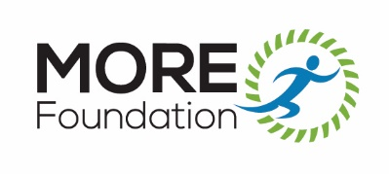
Cancellations received up to 72 hours before the conference will be refunded minus a $20.00 administrative fee. No refunds will be made on cancellations received on or after November 10, 2020.

